**Experiment No. 8**

**Aim:** Implement java programs based on exception handling.

**1. Write a program to demonstrate try, catch and finally blocks.**

import java.util.*;

class except

{

public static void main(String[] args)

{

int num;

Scanner sc = new Scanner(System.in);

try

{

System.out.print("Enter a number: ");

num = sc.nextInt();

System.out.println("You entered: " + num);

}

catch (Exception e)

{ System.out.println("Invalid input. Please enter an integer.");

}

finally

{

System.out.println("Execution completed.");

}

}

}

**Output :**

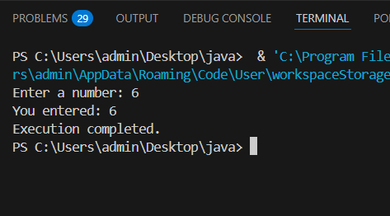

**2. Write a program to divide two numbers using methods and handle the exception**

import java.util.*;

class exception{

public static void divide(int numerator, int denominator)

{

try {

int result= numerator / denominator;

System.out.println("Result: " + result);

}

catch (ArithmeticException e) {

System.out.println("Division by zero is not allowed.");

}

}

public static void main(String args[]){

Scanner sc = new Scanner(System.in);

System.out.print("Enter numerator: ");

int num = sc.nextInt();

System.out.print("Enter denominator: ");

int denom = sc.nextInt();

divide(num, denom);

}

}

**Output :**

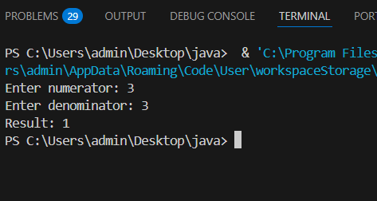

**Code:**

import java.util.*;

class except5

{ public static void main(String args[])

{

int size;

int a[];

Scanner sc=new Scanner(System.in);

System.out.println("Enter size");

size=sc.nextInt();

System.out.println("Enter array elements:");

a=new int[size];

for(int i=0;i<=size-1;i++)

{

a[i]=sc.nextInt();

}

for(int i=0;i<=size-1;i++)

{

System.out.print(a[i] + " ");

}

System.out.println();

System.out.println(a[6]);

}

}

**Output :**

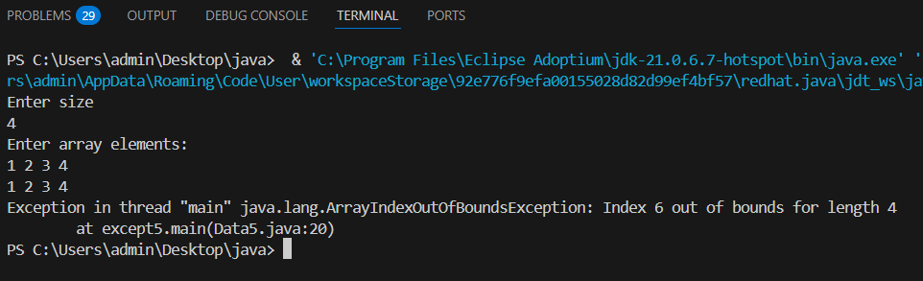

**Code :**

import java.io.*;

class except4

{

public static void main(String args[])

{

int a=10,b=0;

int c=a/b;

System.out.println(c);

}

}

**Output :**

